Precision Plating Corp. Vernon, Ct
Name:
Date:
Course Number:
Instructor’s Name:

Abstract
The Precision Plating Company produces metals that are coated with chromium. They produce this by the process of alkaline cleaning, chemical etching, rinsing, buffing and polishing. These processes take up an enormous amount of water and as a result, a lot of water is drained later. When the production of the materials is done, the balance of used water is stored in trunks that are of gallons. As the trunks are kept outside the factory, the authorities of the factory did not see any effects being caused by the wasted water. This process has been continued ever since the factory started running in 1970. But later on, as years passed, the stored wasted water in the trunks that went unnoticed by authority started forming into harmful acidified waste. Gradually, it was mixed up with the water stream. As a result, the well water nearby the factory started to produce harmful water that was unfit for drinking. Ater on, the cause has come into the notice of the officials Environmental Protection Agency (EPA) and further investigations are being processed. New amendments are proposed by the government to find a better solution and save the environment so the citizens are able to get clean drinking water.

Precision Plating Corp. Vernon, Ct
Introduction
The Precision Plating Corp is a company that plates chromium. Their site is located in Vernon in Connecticut. It is one of the several tenants in a small industrial complex known as the Hillside Industrial Park. The company has been established since 1970 and ever since then they have been chrome plating various metal parts and fixtures on this 3-acre area. As the process of chrome plating kept continuously processing, the waste generated from it was produced into the drinking water wells in the Hillside Industrial Park. Their manufacturing includes chrome plating various metals parts and their fixtures. The manufacturing process includes alkaline cleaning, chemical etching, rinsing, buffing and polishing. The water used for rinsing during this process is drained outside. This water consists of heavy metals, batch wastes of alkaline cleaner and spent plating and etching acids. During their initial days of manufacturing and producing chromium plating metals and their fixtures, the rinsed water that had been considered waste was pushed outside the factory where a large drum was kept. It was the year 1983 then.
The process plating acids and chrome plating wastes were stored in these drums over a volume of 500-gallon tanks. This process went on the coming by years and the contaminated water only kept increasing in amount. It was in the year 1979 it came to the notice of Vernon's Health Department that the water that came from the well in the Hillside Industrial Park was contaminated with hexavalent and trivalent chromium. When further investigated about the waste water, it was found that the continuous rupturing of the drums that contained process plating acids and chrome plating wastes was the cause of the contamination. Later on, a notice was sent to the Environmental Protection Agency (EPA) who tested the water and confirmed that the groundwater underlying the site had become contaminated and as a result the water from the wells nearby will be waste water and harmful for the people. However, the site was put to notice by the National Priorities List (NPL) in October 1989. Our received enquiries were what actions were proposed to clean the site? And most of the people are curious about what is the current situation of the site? As we look forward to explain and bring out a realisation of how much acidifying the environment and harming nature is dangerous, we will be going through the measures and decisions taken by the responsible people to bring out a less harming process and save the environment back to its old condition and as a result, produce clean drinking well water. Kammer, P. A. (2006).
To survey the dangers introduced by risky waste districts, the Environmental Protection Agency (EPA) developed a scoring structure called the Hazard Ranking System (HRS). The Environmental Protection Agency (EPA) uses the information accumulated during the assessment time of the Superfund association to score areas as shown by the danger they may pose to human prosperity and the environment. At the point when the instance of the Precision Plating organization was seen, it was tracked down that this case should be taken in the event that it was getting destructive to the climate step by step.
Site Description and History
The Precision Plating Company in Connecticut takes up approximately 3 acres of the land in Hartford Street. The Precision Plating Corp. Superfund Site is situated at the Hillside Industrial Park at 1050 Hartford Turnpike (Route 30) in the Town of Vernon, Connecticut, and is encircled by a blend of remote low business, private and lacking area. For practicality, the area of the site will be given as the Hillside Industrial Park at 1050 Hartford Turnpike in Vernon, Connecticut. The inexact geographic focus of the site is situated at N 41° 51' 5", W 72° 29' 24". Around 2,500 people live inside one half mile of the Site. As per the Environmental Protection Agency (EPA) Environmental Justice Screening Tool, the Site isn't in a region that warrants further survey concerning ecological equity. The Environmental Protection Agency (EPA) has played out no past expulsion activities at the Site. As for today, the company is said to be closed permanently, there are satellitic pictures that show the site’s description and physical features of the land. For more than thirty years, Environmental Protection Agency (EPA)'s Superfund program and its accomplices have remediated polluted risky waste locales and facilitated local area objectives for reuse. Networks reuse Superfund locales from numerous points of view – parks, malls, athletic fields, natural life safe-havens, fabricating offices, homes and streets.
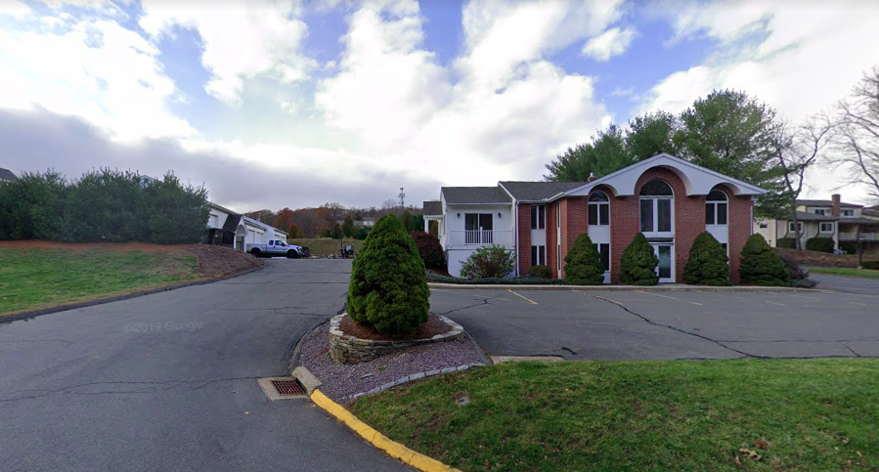
The picture above gives a view of the streets of Hartford where the Precision Plating Company is situated.
The company focused on plating metals with chromium by a lot of scientific processes. These processes include alkaline cleaning, chemical etching, rinsing, buffing and polishing. As we know, water is essential for such processes, a lot of water was used to conduct this process and for a number of gallons of water was taken and used for alkaline cleaning, chemical etching, rinsing, buffing and polishing. The water used was rinsed off through the sewage which was connected to the tanks that were placed outside the company. The company authority did not heed about what the wasted water was developing into. The wasted water stored in the tank was triggered continuously and as a result it contaminated the well water nearby the factory by acidifying it. Later on, by further investigation it was found that the water contained hexavalent and trivalent chromium.
Now, the process of finding a solution to clean up the mess and produce a clean environment was segregated by the authority into two. It was considered as an initial action and a long-term remedial phase. The initial action being the storage of wasted water and producing acidified water in the well which is harmful for the people living by. It was not considered that the chance of the contaminated water to be highly dangerous and also it would be mixed with the well water too. The long-term remedial phase was the action taken by the Environmental Protection Agency (EPA). It was to find the solution to this harmful cause. As it occurred after a long term of processing and formulation, it was to be known that the solution to be found and applied to get an observation will take a prolonged amount of time.
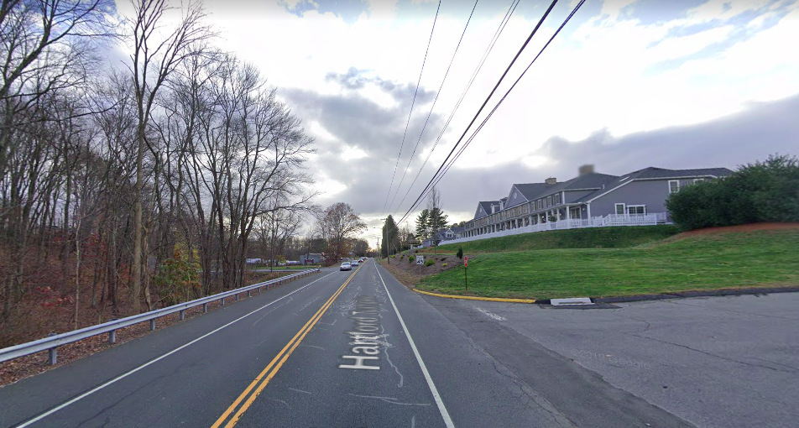
The authorities decided to look into the type of solid, topography and features of the place. The observation of the land where the company is situated which is in Hartford helps in finding an adequate solution to this cause.
Environmental Setting
The Precision Plating Company is situated in the Hartford Turnpike road in Vernon. Alongside the factory was the Hillside Industrial Park. It was the well in Hillside Industrial Park that got contaminated by the water coming from the Precision Plating Company.
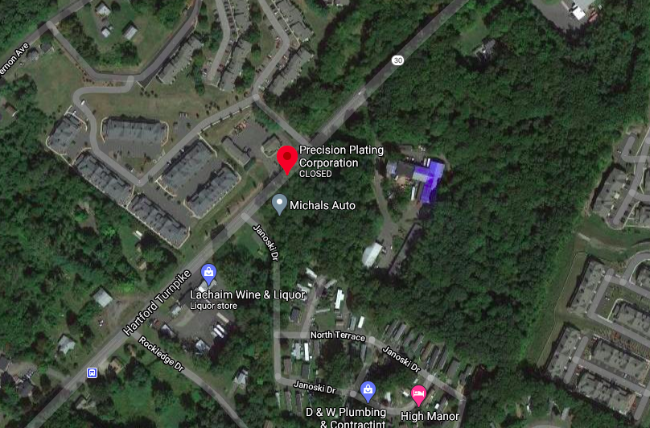
The picture above gives a prtary of the site location of the Precision Plating Company. It is situated in Hartford Street in Connecticut. (Source: Google)
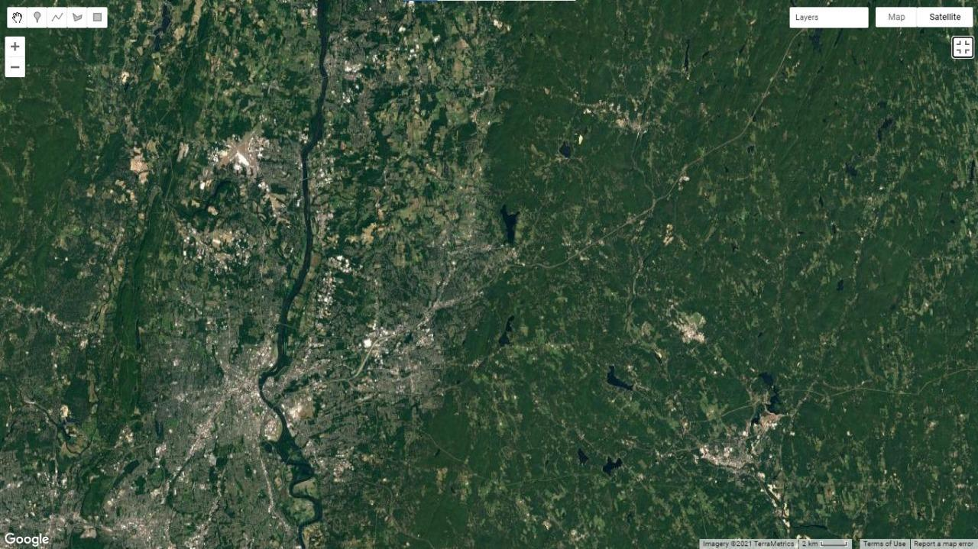
The topography of the site is shown above. (Source: Google Maps).
The type of soil and the topography of a site plays a major role in its reaction to environmental changes. When we look into the type of soils that are situated in the area near the company in Hartford, it was to be found that they had Glacial outwash coarse.
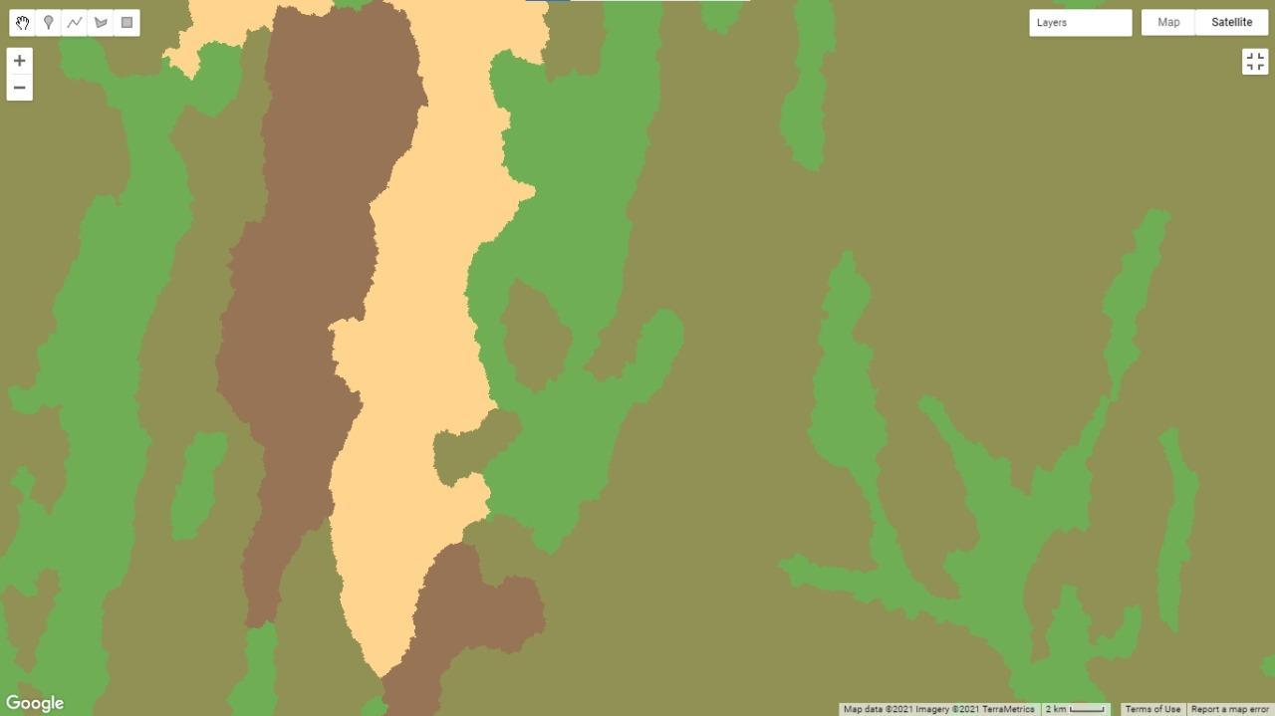

The picture above shows the types of features present in the site Hartford, Vernon (Dataset Source: Theobald, D. M., Harrison-Atlas, D., Monahan, W. B., & Albano, C. M. (2015). Ecologically-relevant maps of landforms and physiographic diversity for climate adaptation planning. PloS one, 10(12), e0143619). The light green color which is seen in areas as striped manners in the site indicates the presence of glacial outwash course.
Glacial outwash coarse means the soil was deposited by transportation due to glacial action and the land is organized into distinct horizontal layers and aso the land consists of round gravel stones or pebbles.
Moreover, the land is more hydric in nature. It is indicated by the brown pigments shown in the above picture. Scientifically, hydric solid are seen mre near wetlands where there is the presence of water bodies. Vernon Street in Connecticut has streams and lakes connected in vast areas and hence the amount of hydric soils is in a large area. The Hillside Industrial Park is surrounded by water bodies like streams and lakes that are connected.
The well water in Hillside Industrial Park comes from these streams and lakes. And hence when the wastewater that is acidified comes from the factory, it intrudes with the freshwater by joining the streams and as a result gets mixed up with the well water making it completely contaminated and harmful. The yellow patch seen in the picture refers to the Alluvium and coastal sediment fine type of soil found in the site. The alluvial coastal solid is formed due to the triggers made by sea waves so it is of tidal origin. Since they are made by tidal waves, they will be more sandy, porous and saline. This is an indication that gives us assurance that the streams, lakes and other water bodies are connected.
Overview of State and Federal Regulatory Issues
From 1989 until 2011 the Department of Energy and Environmental Protection (DEEP) took over the case for this Site. Activities done for the bearing of DEEP incorporated the expulsion of tainted mud from the region quickly around the Precision Plating office, and the association of the Industrial Park and the mechanical park to the current waterline. Profound additionally gave packaged bottled water that is safe to drink to two homes where information demonstrated the presence of chromium (absolute) over the Environmental Protection Agency (EPA) MCL (100 μg/1). Authoritative changes to DEEP's specialists have expected DEEP to as of late stop the inventory of filtered water. ExactnessThe Town of Vernon has been effectively associated with help of the Environmental Protection Agency (EPA) and DEEP's activities.
On November 17, 2015, EPA started giving packaged drinking water as a brief substitute drinking water supply for the entirety of the inhabitants and workers at the Removal Site. From July 27 through September 21, 2016, EPA attempted development exercises to interface the properties situated toward the southwest of the Hillside Industrial Park to the CWC central conduits.
Every one of these properties is currently associated with the public drinking water supply, and the interval filtered water supply has been ended. In this way, EPA has built up a last plan for the expansion of CWC's waterline. EPA went into a Memorandum of Understanding with CWC on September 20, 2017, to encourage the consolidation of the central pipe expansion into their framework.
EPA wanted to introduce the central conduit expansion in October 2107, utilizing the ERRS worker for hire to subcontract with a development firm with experience introducing water mains. Unexpected troubles in executing the sub-contract caused a deferral in the arranged beginning of the undertaking. The development plan incorporates the maintenance of reaction related harm to the influenced street. Such fixes require the accessibility of black-top, and in Connecticut, black-top plants normally don't work in winter conditions.
Since the street harm may not be repairable in an opportune way, EPA discovered that the best game-plan is delay development until spring 2018. Subsequently, an extra exception of as far as possible is mentioned, to permit extra an ideal opportunity to finish the evacuation activity.

Environmental Protection Agency (EPA) issues Records of Decision (RODs) to clarify which cleanup strategies will be utilized at Superfund National Priorities List destinations. The Environmental Protection Agency (EPA) has two essential reports that it might use to distinguish changes to the cures chosen in RODs. The Environmental Protection Agency (EPA) utilizes a ROD Amendment when it needs to roll out a crucial improvement to the cure. The Environmental Protection Agency (EPA) distributes an Explanation of Significant Differences (ESD) for critical changes.
Prior to 1983, site administrators released waste waters to a channel outside the structure and put away interaction plating acids and chrome plating squanders in drums and in a 500-gallon tank. In 1979, Vernon's Health Department discovered chromium defilement in the ground water well serving the Hillside Industrial Park. The organization decided the reason to be the breaking of drums and a capacity tank by a snow furrow. The Environmental Protection Agency (EPA) added the site to the National Priorities List (NPL) in 1989. Beginning cleanup exercises included interfacing close by homes to a public water supply, eliminating defiled soil and observing ground water. While the Connecticut Department of Energy and Environmental Protection (DEEP) at first started examinations of the leftover defilement, in 2010, Environmental Protection Agency (EPA) turned into the lead organization to proceed with this work. The Remedial Investigation and Feasibility Study is right now being created. A draft Remedial Investigation (RI) is expected to be accessible in 2020, and will be trailed by a Feasibility Study (FS) and human wellbeing and environmental danger evaluation. These reports will record the nature and degree of defilement, unsatisfactory openness hazards, and an assessment of expected choices to address site pollutants. A Proposed Plan will be created dependent on these archives and delivered for public remark. A Record of Decision (ROD) will report the chosen cleanup measures. The chromium office keeps on working nearby.

During cleanup, complex destinations might be partitioned into a few unmistakable zones to make the reaction more productive. These regions, called operable units (OUs), may address geographic zones, explicit issues, or medium (e.g., groundwater, soil) where a particular activity is required. The cures are shown for the OU numbers demonstrated in the first choice archive. OU numbers may change over the long haul. The Environmental Protection Agency (EPA) is attempting to improve information quality. NPL and the State have taken chances to participate in taking actions to find solutions to remove the waste water. Their inclusion in Superfund has developed throughout the long term, and states and clans are presently engaged with practically every period of cleanups.
Superfund requires the Environmental Protection Agency (EPA) to facilitate states and clans when the government drives cleanup tasks, and permits states, clans, and nearby governments to lead cleanup endeavors utilizing Superfund’s fund if they have the fundamental specialized and the board skill. To assess the perils presented by unsafe waste locales, the Environmental Protection Agency (EPA) built up a scoring framework called the Hazard Ranking System (HRS). The Environmental Protection Agency (EPA) utilizes the data gathered during the evaluation period of the Superfund interaction to score locales as indicated by the threat they may pose to human wellbeing and the climate. When the case of the Precision Plating Company was looked at, it was found that this case must be taken if it was getting harmful to the environment day by day.
Impending dangers have been limited by uncovering and off-site removal of sullied surface soils. Contact with polluted groundwater has been tended to by giving substitute drinking water supplies to close inhabitants. A Time Critical Removal Action (TCRA) was resolved to be important to address unsatisfactory centralizations of hexavalent chromium in groundwater being used close by mortgage holders and businesses for consumable water. An Action Memorandum for a Time-basic Removal Action (NTCRA) was endorsed by Environmental Protection Agency (EPA) in 2015 to give brief filtered water to influence property and interface another central pipe to a leaving one which runs along the Hartford Turnpike. The Action Memorandum proposed an exception to as far as possible for the evacuation activity for the Precision Plating Corp. Superfund Site (the Site), situated in Vernon, Connecticut. This time-basic expulsion activity is tending to the danger to human wellbeing and the climate presented by risky substances and poisons or impurities in drinking water wells surpassing the Environmental Protection Agency (EPA)'s activity levels. The Site was added to the National Priorities List in 1989 and is as of now going through a Remedial
Examination (RI). The proposed evacuation activities are steady with the healing objectives for the Site, be that as it may, Environmental Protection Agency (EPA)' s healing system can't address the circumstance until the execution of the chosen Remedial Action. The Site will keep on representing a danger to human wellbeing if the Environmental Protection Agency (EPA) doesn't proceed with the reaction activity mentioned in the Action Memorandum. Five influenced properties were associated with this cleanup water supply.

A Community Involvement Coordinator (CIC) has been relegated to this venture. The OSC and CIC plan to meet separately with the proprietors and inhabitants of the homes, and with the owners and administrators of the business properties to clarify the proposed activity. The Environmental Protection Agency (EPA) will keep on organizing with CT DEEP, CT DPH and the Town of Vernon and other included substances, and will give public statements and certainty sheets as required.

Potential Impacts to Human Health and the Environment
As the well water got contaminated due to the acidified water coming from the factory, it damaged the environment and the areas nearby the site. The growth of plants and trees in the Hillside Industrial park was decreased due to the availability of increased waste water. As a result, it causes more harm to the environment.
Impending dangers have been limited by unearthing and off-site removal of sullied surface soils. Contact with debased groundwater has been tended to by giving substitute drinking water supplies to close inhabitants. As well water is contaminated, living beings nearby have lead drinking water. This causes a great impact on the living being nearby the area. This time-basic evacuation activity is tending to the danger to human wellbeing and the climate presented by dangerous substances and poisons or toxins in drinking water wells. Chromium is recorded as a hazardous substance under CERCLA, and is thus seen as a potential or genuine risk to general prosperity and the environment. The Department of Health and Human Services (DHHS), the International Agency for Research on Cancer (IARC) and Environmental Protection Agency (EPA) have organized Cr6 as a disease causing specialist. The fundamental human prosperity transparency risk at the saw levels of Cr6 is through ingestion, while dermal contact addresses a lesser peril. The potential for transparency at the Site to conceivably damaging measures of Cr6 through internal breath isn't considered to be gigantic.
Without the reaction activity portrayed here, the dangers related with the presence of Cr6, PFOA and PFOS in private wells will endure. Postponed activity could build public wellbeing chances presented by direct openness to the previously mentioned risky substance, poisons or toxins and the likely relocation of pollution in groundwater. Real or compromised arrivals of perilous substances from this Site, if not tended to by carrying out the reaction activity chose in this Action Memorandum, may introduce a fast approaching and significant risk to general wellbeing, or government assistance, or the climate. In understanding with OSWER Directive (August 19, 1993) (17], a risk assurance is made dependent on "fitting Superfund strategy or direction, or on cooperation with a prepared danger assessor." "Fitting sources incorporate, however are not restricted to, EPA significant activity level or tidy up norms, Agency for Toxic Substances and Disease Registry (ATSDR) records or faculty, or staff toxicologists."
For this situation, EPA depended on EPA's distributed RMLs, and talked with the CT DPH, which upholds the utilization of the RML as a wellbeing defensive level for the arrangement of an elective water supply for those properties with private wells affected by the Site.
The danger to drinking water supplies exists dependent on er6 fixations surpassing the RML in private and business wells. Also, there is potential for the centralization of Cr6 in these wells to increment over the long haul, as they give off an impression of being hydrologically connected to a feasible defilement source, the Precision Plating office, with higher groundwater focuses

Table 1: Maximum contaminated levels in groundwater monitoring wells.
Contaminants | Total in underground  Well water  (μg/l) | Total in domestic and commercial well (μg/l) | MCL (μg/l) | RML (μg/l)
Chromium (total) | 3,400 | 523 | 100 | None
Chromium (hexavalent) | 3,290 | 482 | None | 3.5

Openness to specific degrees of PFOA and PFOS through drinking water may result in antagonistic wellbeing impacts, including formative impacts to hatchlings during pregnancy
or on the other hand to breastfed babies (e.g., low rate of birth, sped up adolescence, skeletal varieties), disease (e.g., testicular, kidney), liver impacts (e.g., tissue harm), invulnerable impacts (e.g., counter acting agent creation and resistance), thyroid impacts and different impacts (e.g., cholesterol changes).
Summary of Phase I Environmental Site Assessment
The Connecticut Department of Energy and Environmental Protection (DEEP, earlier the Branch of Environmental Protection) researched, and guided Precision Plating to accept response exercises, including the assessment of the level of polluting, the ejection of tarnished soil from the zone rapidly around the Precision Plating office, additionally, the relationship of the maid house park and the cutting edge park to a momentum waterline. The Environmental Protection Agency (EPA) proposed the Site for expansion to the National Priorities List (NPL) on June 24, 1988.
The Site was recorded on the NPL on October 10, 1989. In September 1998, an Enforcement Agreement among Environmental Protection Agency (EPA) and DEEP settled DEEP as the lead office for the Site cleanup as a non-Fund financed, state-lead implementation reaction activity. The Enforcement Agreement considered that the reaction activity would be subsidized by the Site land owner instead of using Superfund or other DEEP assets. Under the heading of DEEP, Site examination exercises advanced. In 2011, Environmental Protection Agency (EPA) and DEEP concurred that it would be to the greatest advantage of the Site to disavow the Enforcement Agreement.
The lead organization job was moved back to Environmental Protection Agency (EPA), and a Remedial Investigation/Feasibility Study (RifFS) was started. The Environmental Protection Agency (EPA) continued the drinking water well examining program originally acquainted by DEEP with remembering the majority of the homes and organizations for the zone. These properties have had their wells tested constantly since 2012. Logical information demonstrates that most of the all-out chromium identified is in the hexavalent·form (Cr6), and that there is a pattern of expanding levels of both aggregate and Cr6 in a considerable lot of the wells.
A Private Well Water Interim Human Health Assessment was performed, and five drinking water wells were recognized to introduce gradual lifetime malignancy hazard more noteworthy than 10-4, in view of Cr6 focuses. The essential segment to the danger is identified with ingestion, while dermal contact (for example through washing) gives an optional danger. The danger from openness to Cr6 through inward breath isn't viewed as critical.
Summary of Phase II and III Environmental Site Assessment
Neither DEEP nor the Town of Vernon has the assets to give associations with the CWC water line, which would be a lasting cure, or to give a stockpile of filtered water to occupants and organizations uncertainty.
In any case, DEEP, CT DPH and the Town of Vernon will keep on working with the Environmental Protection Agency (EPA) on this expulsion activity to the degree conceivable. The prescribed activity is to broaden the CWC water framework and give associations with homes furthermore, organizations with drinking water wells containing hexavalent Cr6 at fixations over the Environmental Protection Agency (EPA) RML of 3.5 μg/l.
The Environmental Protection Agency (EPA), after meeting with the Connecticut Department of Public Health (CT DPH), has verified that the RML would be a material cleanup level prerequisite for this proposed evacuation activity. The Town of Vernon Engineering Department will be effectively associated with this task. The Town of Vernon will probably help with facilitating and advancing future public effort gatherings. CT DEEP and CT DPH will offer help to the Environmental Protection Agency (EPA) during efforts to illuminate and prompt inhabitants and entrepreneurs.
CT DPH will likewise keep on giving toxicology and wellbeing hazard openness support as a feature of their helpful concurrence with the Agency for Toxic Substances also, Disease Registry (ATSDR). CT DEEP and the Town of Vernon will be mindful to carry out institutional controls as decided fundamentally.
Conceptual Site Model
The Environmental Protection Agency (EPA) proposes to give water to all homes and business properties at the Removal site with Cr6 defilement over the 3.5 μg/l RML, by offering to associate them to the CWC water framework. Properties situated toward the southwest of the Hillside Industrial Park would be associated with the current CWC central pipes.
For properties situated toward the upper east, Environmental Protection Agency (EPA) proposes to develop a water line expansion of the CWC water framework, Environmental Protection Agency (EPA), CT DPH and the Town of Vernon will unequivocally empower property holders with private wells debased with Cr6 over Environmental Protection Agency (EPA)'s RML of3.5 μg/l to acknowledge the association offer. The evacuation exercises will incorporate perceiving properties at the Site, with Cr6 debasement outperforming the RML to be related with the help and choosing express necessities of their property.
Lead a Removal site walk around ERRS laborers for enlist, CT DPH and Town of Vernon specialists to overview site plan and choose required stuff, staff and backing. Give bundled drinking water to impact occupants and business associations as a span measure. Create and complete a site-unequivocal Health and Safety Plan (HASP). Build up a site-unequivocal work plan giving assessments of materials, time and costs. Prepare labor force and equipment.
Associates doled out homes and business properties to the flow CWC water standard and make significant following isolates from the momentum private systems. Create plan conclusions for an increase of CWC's focal conductor along Hartford Interstate toward the upper east of the Hillside Industrial Park.
Develop the focal conductor increase according to the arrangement points of interest. Eliminate from organization all private wells doled out by the land proprietors. Give site security relying upon the circumstance.
Summary of Remedial Action Plan (RAP)
As a component of the on-going Remedial Investigation (RI) for the NPL Site, in April 2016, Environmental Protection Agency (EPA) tested observing wells around the Precision Plating office, just as a restricted number of drinking water wells, for PFAS compounds, in light of data that Accuracy Plating may have utilized PFAS-containing froth in their tasks.
PFOS was identified in observing wells at fixations going from 0.16 µg/1 to 2.5 µg/1. PFOA was distinguished in one observing great at a convergence of 0.09 µg/1. PFOS was distinguished in two private drinking water wells at 0.15 µg/1 and 0.17 µg/1. The Environmental Protection Agency (EPA) is previously giving an elective water supply to these homes as a feature of the evacuation activity.
Table 2: Site Milestone
Milestone | Date(s)
Initial Assessment Completed | 01/01/1985
Proposed to the National Priorities List | 06/24/1988
Finalized on the National Priorities List | 10/04/1989
Remedial Investigation Started | 08/26/2011
Final Remedy Selected | Estimated Sep - Nov 2022
Remedial Action Started | Not Yet Achieved
Construction Completed | Not Yet Achieved
Deleted from National Priorities List | Not Yet Achieved
Most Recent Five-Year Review | Not Yet Achieved
Site Ready for Reuse and Redevelopment | Not Yet Achieved
Source:(https://cumulis.epa.gov/supercpad/SiteProfiles/index.cfm?fuseaction=second.schedule&id=0100156)
Remedial Strategies Used and Results
The National Priorities List (NPL) is the rundown of destinations of public need among the known deliveries or compromised arrivals of perilous substances, poisons, or pollutants all through the United States and its domains. The NPL is proposed fundamentally to manage the Environmental Protection Agency (EPA) in figuring out which destinations warrant further examination.
The Action Memorandum affirmed on September 9, 2015 approved Environmental Protection Agency (EPA) to give water to all homes and business properties at the expulsion Site with Cr6 pollution over the 3.5 µg/1 RML. Properties situated toward the southwest of the Hillside Mechanical Park have been associated with the current CWC central conduits. The proposed 12- month exception and roof increment will permit the Environmental Protection Agency (EPA) to develop a water line expansion of the CWC water framework and interface the properties toward the upper east. Explicit expulsion exercises that will proceed incorporate the accompanying:
• Give bundled drinking water to impact inhabitants and business associations as a span measure.
• Create plan specifics for an enlargement of CWC's focal line along Hartford Expressway toward the upper east of the Hillside Industrial Park.
• Create plan details for an augmentation of CWC's central conduit along Hartford Freeway toward the upper east of the Hillside Industrial Park.
• Build the central pipe expansion as per the plan particulars.
• Associate assigned homes and business properties to the central conduit expansion what's more, make important ensuing separates from the current private frameworks.
• Eliminate from administration all private wells assigned by the land owners.
• Give the site with the required protection.
The OSC will facilitate with State authorities to recognize State ARARs, assuming any. In agreement with the National Contingency Plan and EPA Guidance Documents, the OSC will decide the practicability conforming with each State ARAR distinguished in a convenient way.
The OSC expects this time-basic evacuation activity to start at the earliest opportunity after endorsement of the Action Memorandum and the commitment of financing. The assessed length of the venture is around a year once development starts.

Table 3: Estimated cost
Cost category  (Contractors) | Current ceiling | Proposed increase | Proposed ceiling
ERRS | $1,000,000.00 | $100,000.00 | $1,100,000.00
RACs | $100,000.00 | $400,000.00 | $500,000.00
START | $50,000.00 | $50,000.00 | $100,000.00
Subtotal existing outside | $1,150,000.00 | $550,000.00 | $1,700,000.00
Extramural contingency (10%) | $115,000.00 | $55,000.00 | $170,000.00
Total, removal action ceiling | $1,265,000.00 | $605,000.00 | $1,870,000.00
(Source: https://semspub.epa.gov/work/01/595318.pdf)

Direct Costs incorporate the Subtotal existing outside expenses $1,870,000 and direct intramural expenses $100,000.
Aberrant costs are determined by utilizing provincial roundabout rate basically at time quote is arranged, and is communicated as a level of the immediate costs 48.67% x $, predictable with Environmental Protection Agency (EPA)'s full expense bookkeeping procedure powerful October 01, 2016.
These appraisals do exclude pre-judgment interest, don't consider other implementation costs, including Department of Justice costs, and might be changed over the span of an evacuation activity. The appraisals are for illustrative purposes just and their utilization isn't proposed to make any rights for people in question.
Neither the absence of an all-out quote nor deviation of genuine all out costs from this gauge will influence the United States' righil: to cost recuperation.
The Addendum will alter the degree to permit EPA to give, to the degree practicable, an substitute water supply to extra homes or business properties that might be recognized with drinking water well focuses surpassing either the Removal Management Levels (RML) for hexavalent chromium or the Health Advisory level for PFOS as well as PFOA because of the potential for expanded openness because of groundwater tuft relocation.
Likewise, the Addendum will expand the complete extramural undertaking roof to $1,870,000.00 (from $1,265,000.00); and will take into consideration an extra a year for project fulfillment.
EPA has built up a starter plan for the augmentation of CW C's waterline to support the leftover affected wells. EPA is planning with CWC to consolidate their remarks into the last plan, and to encourage the consolidation of the central conduit augmentation into their framework.
In the quote for the first Action Memorandum, the intricacy of the water fundamental plan was belittled. Subsequently, extra financing and extra time will be expected to finish the expulsion action. Accordingly, an exception of the year limit is mentioned.
Current Site Status
Precision Plating Corp. consented to state orders in 1986 and introduced five shallow checking wells, tested surface water, took out 20 cubic yards of defiled soil and gave substitute drinking water supplies to a trailer park toward the south. In 1998, Environmental Protection Agency (EPA) went into a concurrence with the Connecticut Department of Environmental Protection (CT DEP) wherein the state consented to start to lead the pack nearby administration. In 2011, the venture moved under government lead. CT DEP, presently the Connecticut Department of Energy and Environmental Protection (CT DEEP), is working with Environmental Protection Agency (EPA) to research the site and concoct a cleanup plan. An examination concerning the nature and degree of defilement at the site started in October 2002 under CT DEEP position. Environmental Protection Agency (EPA)'s examination started in May 2012 and is at present continuous. A draft Remedial Investigation (RI) archiving all information gathered at the site is expected to be accessible in 2020. This will be trailed by a draft Feasibility Study (FS) of cleanup options and a human wellbeing and natural danger appraisal. These archives will uphold a proposed cleanup plan, to be delivered to general society for input, before reporting a ultimate choice in a Record of Decision (ROD).
Summary
The Precision Plating Company in Vernon produces metals that are coated with chromium. The organization focused on plating metals with chromium by a ton of logical cycles. These cycles incorporate antacid cleaning, synthetic drawing, flushing, polishing and cleaning.
As we probably are aware, water is fundamental for such cycles, a great deal of water was utilized to direct this interaction and for various gallons of water was taken and utilized for antacid cleaning, compound drawing, washing, polishing and cleaning. The water utilized was washed off through the sewage which was associated with the tanks that were put outside the organization. The organization authority didn't regard what the squandered water was forming into. The squandered water put away in the tank was set off consistently and therefore it defiled the well water close to the plant by acidifying it. Further investigation resulted in finding hexavalent compounds and Cr6 in the drinking water.
As per the Action Memorandum endorsed on September 9, 2015, Environmental Protection Agency (EPA) is making moves to give water to all homes and business properties at the Removal site with Cr6 defilement over the 3.5 µg/l Removal Management Level (RML), by associating them to the Connecticut Water Company (CWC) water framework. On November 17, 2015, Environmental Protection Agency (EPA) began giving bundled drinking water as a transient substitute drinking water supply for the whole of the occupants and laborers at the Removal Site. From July 27 through September 21, 2016, Environmental Protection Agency (EPA) endeavored advancement activities to interface the properties arranged toward the southwest of the Hillside Industrial Park to the CWC focal lines.
Every one of these properties is presently associated with the public drinking water supply, and the between time filtered water supply has been ended. Consequently, the Environmental Protection Agency (EPA) has built up a last plan for the expansion of CWC's waterline. The Environmental Protection Agency (EPA) went into a Memorandum of Understanding with CWC on September 20, 2017, to encourage the consolidation of the central conduit augmentation into their framework.

The Environmental Protection Agency (EPA) wanted to introduce the central pipe expansion in October 2107, utilizing the ERRS worker for hire to subcontract with a development firm with experience introducing water mains. Unexpected challenges in executing the sub-contract caused a deferral in the arranged beginning of the task.
The development plan incorporates the maintenance of reaction related harm to the influenced street. Such fixes require the accessibility of black-top, and in Connecticut, black-top plants as a rule don't work in winter conditions. Since the street harm may not be repairable in an opportune way, the Environmental Protection Agency (EPA) established that the best strategy is deferring development until spring 2018. Subsequently, an extra exclusion of as far as possible is mentioned, to permit extra an ideal opportunity to finish the evacuation activity.
Conclusion
The Precision Plating Corp is an organization that plates chromium. Their site is situated in Vernon in Connecticut. It is one of the few occupants in a little modern complex known as the Hillside Industrial Park. The organization has been set up since 1970 and since the time then they have been chrome plating different metal parts and apparatuses on this 3-section of land region. As the cycle of chrome plating kept persistently handling, the waste created from it was delivered into the drinking water wells in the Hillside Industrial Park. Their assembling incorporates chrome plating different metals parts and their apparatuses.
The assembling cycle incorporates soluble cleaning, substance carving, flushing, polishing and cleaning. The water utilized for flushing during this interaction is depleted outside. This water comprises hefty metals, clump squanders of soluble cleaner and spent plating and scratching acids.
During their underlying long periods of assembling and delivering chromium plating metals and their apparatuses, the flushed water that had been viewed as waste was pushed outside the production line where a huge drum was kept. It was the year 1983 at that point. The interaction plating acids and chrome plating squanders were put away in these drums over a volume of 500-gallon tanks.
This cycle went on for years and the sullied water just continued expanding in large amounts. It was in the year 1979 it went to the notification of Vernon's Health Department that the water that came from the well in the Hillside Industrial Park was debased with hexavalent and trivalent chromium. At the point when further examined about the waste water, it was tracked down that the constant breaking of the drums that contained cycle plating acids and chrome plating squanders was the reason for the tainting. Later on, a notification was shipped off the Environmental Protection Agency (EPA) who tried things out and affirmed that the groundwater hidden the site had gotten tainted and subsequently the water from the wells close by will be squander water and unsafe for individuals. Nonetheless, the site was put on display by the National Priorities List (NPL) in October 1989.
As we anticipate, clarify and draw out an acknowledgment of what amount acidifying the climate and hurting nature is risky, we will be going through the actions and choices taken by the mindful individuals to draw out a less hurting interaction and save the climate back to its old condition and therefore, produce clean drinking great water. The Environmental Protection Agency (EPA) has approached giving bundled drinking water to impact occupants and business associations as a stretch measure.
Create and do a site-unequivocal Health and Safety Plan (HASP). Build up a site-express work plan giving assessments of materials, time and costs. Assemble labor force and equipment. Associate allocated homes and business properties to the ebb and flow CWC water guideline and make significant following isolates from the momentum private systems.
Create plan judgments for an increase of CWC's focal course along Hartford Interstate toward the upper east of the Hillside Industrial Park. Build the focal course increase according to the arrangement specifics. Eliminate from organization all private wells allotted by the land proprietors. Give site security relying upon the circumstance.
Alternative Site Characterization and Remedial Action Strategies
As a feature of the on-going RI/FS, Environmental Protection Agency (EPA) is attempting to describe the hydrogeology at the Site. Although the examination isn't finished, insightful information from tests gathered from checking, private and business wells show the presence of raised centralizations of chromium tainting in the groundwater spring underneath the Precision Plating office. Because of this proposed evacuation activity, the site is considered to incorporate the groundwater spring. The on-going drinking water checking program incorporates occasional examining of 33 private and business wells. The entirety of the drinking water wells fill in as the sole water supply source to their individual homes or organizations. The proposed evacuation activity will address just properties where scientific outcomes show groupings of Cr6 surpassing the Removal Management Level (RML) in drinking water wells.
These properties are completely situated on the part of the Precision Plating Corp. Superfund Site situated along Hartford Turnpike. Accordingly, with the end goal of this proposed expulsion activity, the expression "the Removal Site" is planned to allude explicitly to this part of the Precision Plating Corp. Superfund Site. A central pipe claimed by the Connecticut Water Company (CWC). an exclusive local area water supplier, runs along a part of Hartford Turnpike, and is the nearest provider of consumable water.
Private and business properties on Hartford Turnpike toward the southwest of the Hillside Mechanical Parks are fronted by the central conduit, while properties toward the upper east are definitely not. The CWC central conduits are the solitary practical source nearby for an elective water supply.
Roughly 2,500 people live inside one half mile of the Site. As indicated by the EPA Natural Justice Screening Tool, the Site isn't in a territory that warrants further audit with regard to natural equity. EPA has played out no past expulsion activities at the Site.
A central pipe possessed by the Connecticut Water Company (CWC). an exclusive local area water supplier, runs along a part of Hartford Turnpike, and is the nearest provider of consumable water. Private and business properties on Hartford Turnpike toward the southwest of the Hillside Mechanical Park are fronted by the central conduit, while properties toward the upper east are definitely not. The CWC central pipes is the lone suitable source nearby for an elective water supply. The Site was added to the National Priority List in 1989 and is presently going through a Medicinal Investigation (RI). The proposed evacuation activities are reliable with the healing objectives for the Site, anyway EPA' s healing project can't address the circumstance until the execution of the chose Remedial Action.
The Action Memorandum supported on September 9, 2015 endorsed Environmental Protection Agency (EPA) to offer water to all homes and business properties at the removal Site with Cr6 contamination over the 3.5 µg/1 RML. Properties arranged toward the southwest of the Hillside Modern Park have been related with the current CWC focal lines.
The proposed year prohibition and rooftop addition will allow the Environmental Protection Agency (EPA) to construct a water line development of the CWC water structure and partner the properties toward the upper east. Unequivocal departures practices that will continue join the going with are as follows:
• Provide packaged drinking water to influence occupants and business organizations as an
between time measure;
• Create plan subtleties for a development of CWC's focal line along Hartford Freeway toward the upper east of the Hillside Industrial Park.
• Create plan specifics for an extension of CWC's focal channel along Hartford Interstate toward the upper east of the Hillside Industrial Park.
• Construct the central conduit augmentation as per the plan details.
• Associate relegated homes and business properties to the focal line extension what's more, make fundamental following isolates from the current private systems.
• Remove from administration all private wells assigned by the land owners;
• Give site security dependent upon the situation.
• Repair reaction related harms.
• Retire resources.
The proposed change to the affirmed extent of work for this evacuation activity will approve expulsion activities to secure general wellbeing, government assistance, and the climate from the dangers recognized in Section IV by giving an elective stock of consumable water, in the
occasion that extra homes or organizations are recognized in the RI , with drinking water wells that have been affected by the Site at levels surpassing the RML for Cr6 (3.5 µg/1).
Although these were the proposed amendments, what worked out for the site was as follows:

• Provide packaged drinking water to influence inhabitants and business organizations as an between time measure;
• Where practicable, present place of usage treatment systems (for PFOA and PFOS in a manner of speaking).
• Where practicable, interface allocated homes and business properties to the current CWC focal lines and make fundamental coming about withdrawals from the current private structures.
• Remove from administration all private wells assigned by the land owners.
• Provide site security on a case by case basis;
• Repair reaction related harms; and
• Demobilize asset
References
Ashbolt, N. J. (2004). Microbial contamination of drinking water and disease outcomes in developing regions. Toxicology, 198(1-3), 229-238.
Barth, M. E., & McNichols, M. F. (1994). Estimation and market valuation of environmental liabilities relating to superfund sites. Journal of Accounting Research, 32, 177-209.
Dietz, T., & Stern, P. C. (2002). Exploring new tools for environmental protection. New tools for environmental protection: education, information, and voluntary measures, 3(8).
Greenstone, M., & Gallagher, J. (2008). Does hazardous waste matter? Evidence from the housing market and the superfund program. The Quarterly Journal of Economics, 123(3), 951-1003.
Hird, J. A. (1993). Environmental policy and equity: The case of Superfund. Journal of Policy Analysis and Management, 12(2), 323-343.
Holme, R. (2003). Drinking water contamination in Walkerton, Ontario: positive resolutions from a tragic event. Water Science and Technology, 47(3), 1-6.
Hudak, J. P. (2011). NOTE: Stream diversion management to improve water quality in a Connecticut water supply reservoir. Lake and Reservoir Management, 27(1), 41-47.
Jiuhui, Q. U. (2008). Research progress of novel adsorption processes in water purification: a review. Journal of environmental sciences, 20(1), 1-13.
Kammer, P. A. (2006). OSHA's Occupational Exposure Standard For Hexavalent Chromium Challenges and An Opportunity. Spraytime, 13(3), 1-2.
Moffat, I., Martinova, N., Seidel, C., & Thompson, C. M. (2018). Hexavalent chromium in drinking water. Journal‐American Water Works Association, 110(5), E22-E35.
Sax, J. L., & Conner, R. L. (1972). Michigan's Environmental Protection Act of 1970: A Progress Report. Michigan Law Review, 70(6), 1003-1106.
Scott, S., & Eakins, J. (2009). Environmental Protection.
Sedman, R. M., Beaumont, J. A. Y., McDonald, T. A., Reynolds, S., Krowech, G., & Howd, R. (2006). Review of the evidence regarding the carcinogenicity of hexavalent chromium in drinking water. Journal of environmental science and health part C, 24(1), 155-182.
Sharma, S., & Bhattacharya, A. (2017). Drinking water contamination and treatment techniques. Applied Water Science, 7(3), 1043-1067.
Smith, A. H., & Steinmaus, C. M. (2009). Health effects of arsenic and chromium in drinking water: recent human findings. Annual review of public health, 30, 107-122.
World Health Organization. (2020). Chromium in Drinking-water (No. WHO/HEP/ECH/WSH/2020.3). World Health Organization.

